Part Number: PU060-08015-P1

Kit Contents
Item # | Quantity Reqd. | Description
1 | 1 | Front Passenger Side Mudguard
2 | 1 | Front Driver Side Mudguard
3 | 1 | Rear Passenger Side Mudguard
4 | 1 | Rear Driver Side Mudguard
5 | 2 | Hardware Kit
6 | 1 | Instruction Sheet (Electronic Copy)
Hardware Bag Contents
Item # | Quantity Reqd. | Description
1 | 6 | #10 x 15 mm Screws (short)
2 | 4 | #10 x 19 mm Screws (long)
3 | 6 | #10 Spring Clips (short)
4 | 2 | #10 Spring Clips (long)
Additional Items Required For Installation
Item # | Quantity Reqd. | Description
1
2
3
Conflicts
Recommended Tools
Personal & Vehicle Protection | Notes
None
Special Tools | Notes
None
Installation Tools | Notes
Screwdriver | Phillips #2 & 3, Flat Blade
Drill | Standard/Right Angle
Drill Bits | 2.5 mm ( 3/32” )
 | 6 mm ( 1/4” )
Clean Cloth/Rag
Special Chemicals | Notes
Soap & Water Mixture
General Applicability
Recommended Sequence of Application
Item # | Accessory
1
2
3
*Mandatory
Vehicle Service Parts (may be required for reassembly)
Item # | Quantity Reqd. | Description
1
2
3
Legend
STOP: Damage to the vehicle may occur. Do not proceed until process has been complied with.
OPERATOR SAFETY: Use caution to avoid risk of injury.
CAUTION: A process that must be carefully observed in order to reduce the risk of damage to the accessory/vehicle and to ensure a quality installation.
TOOLS & EQUIPMENT: Used in Figures calls out the specific tools and equipment recommended for this process.
REVISION MARK: This mark highlights a change in installation with respect to previous issue.
SAFETY TORQUE: This mark indicates that torque is related to safety.

Care must be taken when installing this accessory to ensure damage does not occur to the vehicle. The installation of this accessory should follow approved guidelines to ensure a quality installation.

These guidelines can be found in the "Accessory Installation Practices" document.

This document covers such items as:-
- Vehicle Protection (use of covers and blankets, cleaning chemicals, etc.).
- Safety (eye protection, rechecking torque procedure, etc.).
- Vehicle Disassembly/Reassembly (panel removal, part storage, etc.).
- Electrical Component Disassembly/Reassembly (battery disconnection, connector removal, etc.).

Please see your Toyota dealer for a copy of this document.

Prepare to Mount the Front Mudguards.
  - Clean and degrease the front body panel on the driver’s side where the mudguard will be located with a clean cloth and VDC approved cleaner or soap/water mixture.
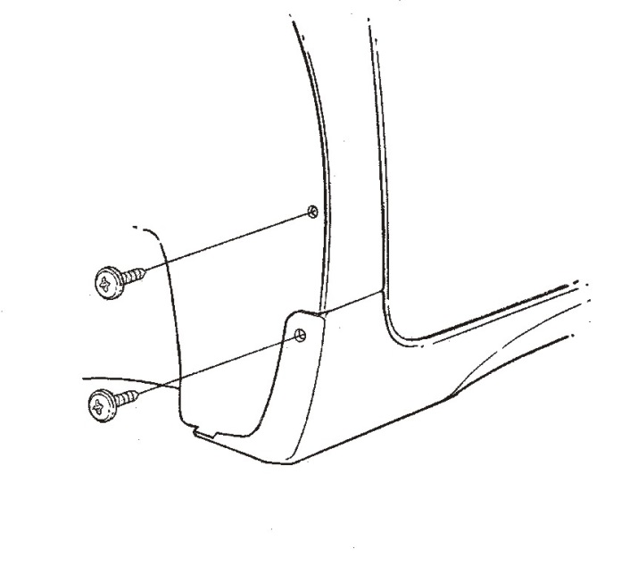
  - Remove the exisiting screws, locations A and B (Fig. 1-1). DO NOT DISCARD THEM.
Fig. 1-1
#3 Phillips screwdriver
Existing Screws
A
B

Install the Front Mudguards.
  - Hold the part up and into the body panel.
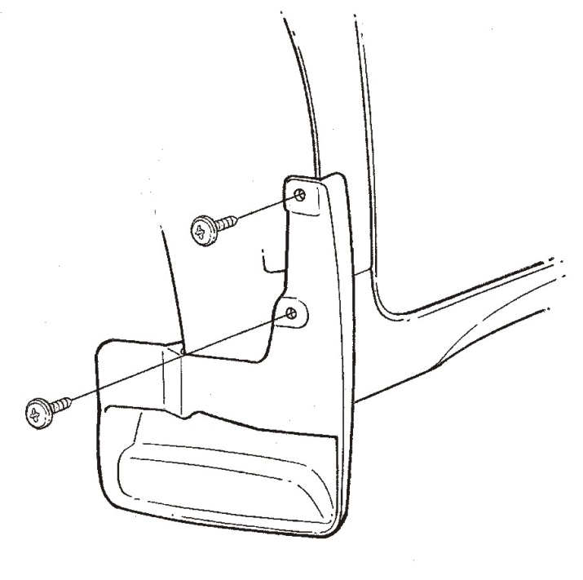
  - Reinstall the OE screws in locations A and B (Fig. 2-1).
Fig. 2-1
#3 Phillips screwdriver
Factory Screws
A
B
Mudguard

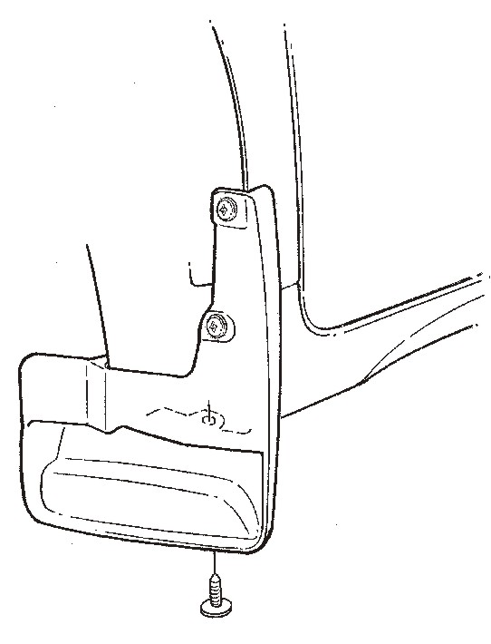
  - Hold the part in position and drill a 2.5mm (3/32”) pilot hole in location C (Fig. 2-2).
Fig. 2-2
#2 Phillips screwdriver, drill motor & 2.5mm drill
C
Supplied 19mm screw (long)
  - Hold the part into the body panel and install a supplied 19mm (long) self-tapping screw into location C (Fig. 2-2).
  - Repeat Steps 1 and 2 on the passenger’s side.

Prepare to Mount the Rear Mudguards.
  - Clean and degrease the rear body panel on the driver’s side where the mudguard will be located with a clean cloth and VDC approved cleaner or soap/water mixture.

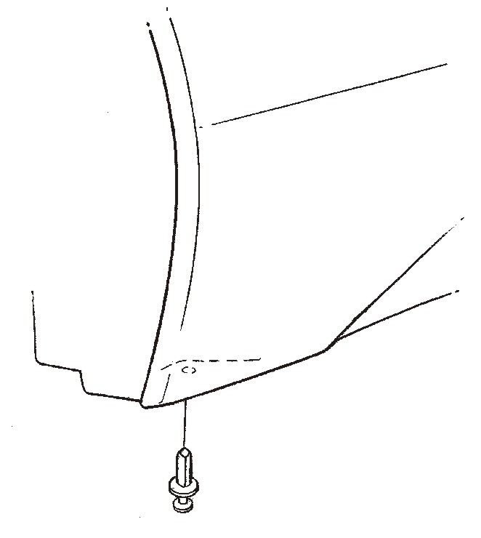
  - Remove the exisiting push pin, location D, and discard it (Fig. 3-1).
Fig. 3-1
Flat blade screwdriver
Existing push pin (discard)
D

Install the Rear Mudguards.
  - Hold the part up and into the body panel.
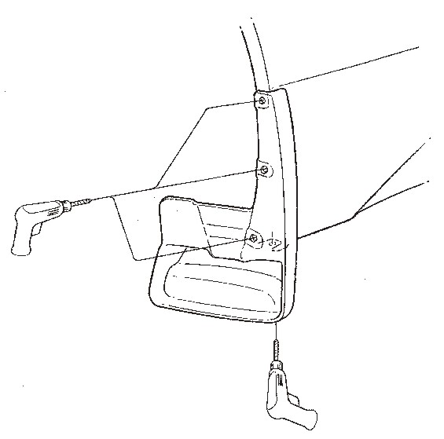
  - Use the part as a template and drill 6mm (1/4”) holes in the panel edge at locations A, B and C (Fig. 4-1).
Fig. 4-1
Drill motor & 2.5mm drill
6mm drill bit
A
D
Passenger’s side only
Mudguard
Drill motor
B
C
NOTE: For easier accessibility, the wheels can be removed or use a right-angle drill motor.
  - Passenger’s side only: Hold the part up and into the body panel and drill at location D (Fig. 4-1).

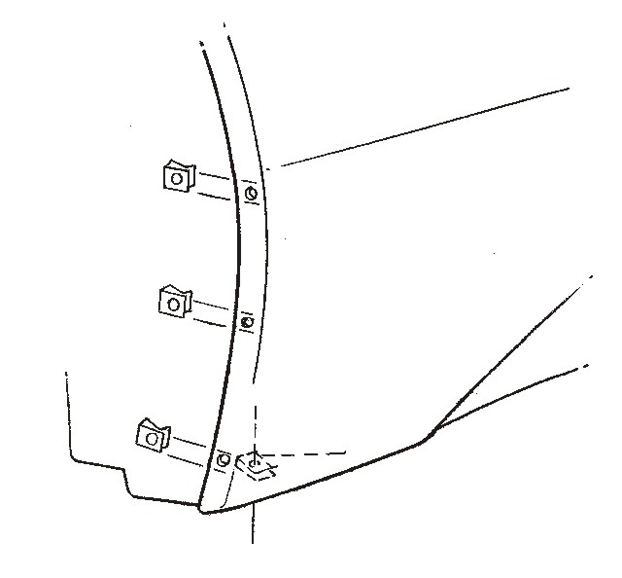
  - Install the supplied spring clips (small) over the panel edge holes at location A, B and C (Fig. 4-1 & Fig. 4-2).
Fig. 4-2
Spring clip (long)
Supplied spring clips (small)
NOTE: The turned up edge goes on the inside of the panel.
  - Pull the rear liner down and install a supplied spring clip (long) over the panel edge hole at location D (Fig. 4-1 & Fig. 4-2).
NOTE: The turned up edge goes on the inside of the panel.

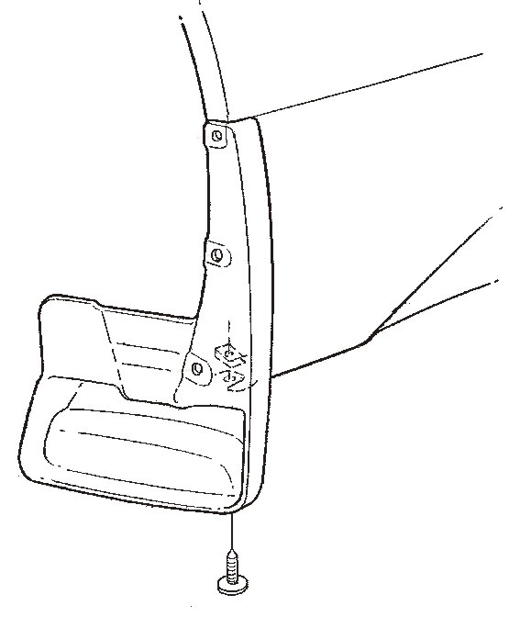
  - Driver’s side only: Hold the mudguard up and into the body panel and install the supplied 19mm (long) screw in location D (Fig. 4-3).
Fig. 4-3
#2 Phillips screwdriver
Supplied 19mm screw (long)
D
Supplied spring clip (long)
  - Passenger’s side only: Hold the part up and into the body panel and install the supplied 19mm screw (long) and the #10 spring clip (long) as a nut in location D (Fig. 4-3).

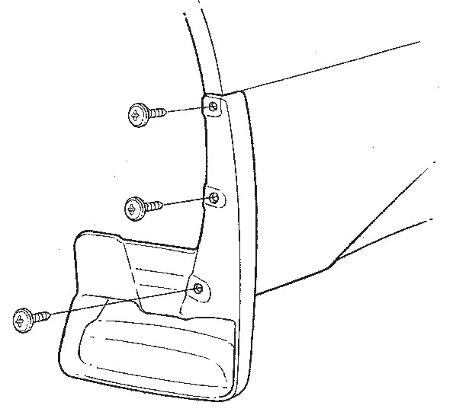
  - Hold the mudguard up and into the body panel and install the supplied 15mm (short) screws in locations A, B and C (Fig. 4-4).
Fig. 4-4
#2 Phillips screwdriver
A
Mudguard
B
C
Supplied screws (short)
  - Repeat Steps 3 and 4 on the passenger’s side.

Accessory Function Checks
Gap between the mudguard and the body

Vehicle Function Checks

Excessive gaps greater than 1.0 mm

Vehicle Appearance Check
After accessory installation and removal of protective cover(s), perform a visual inspection.

Ensure no damage (including scuffs and scratches) was caused during the installation process.
(For PPO installations, refer to TMS Accessory Quality Shipping Standard.)

